36U ENCLOSURE 19" CABINET 600X1000 FLOOR STANDING SERVER RACK - VALUCAB
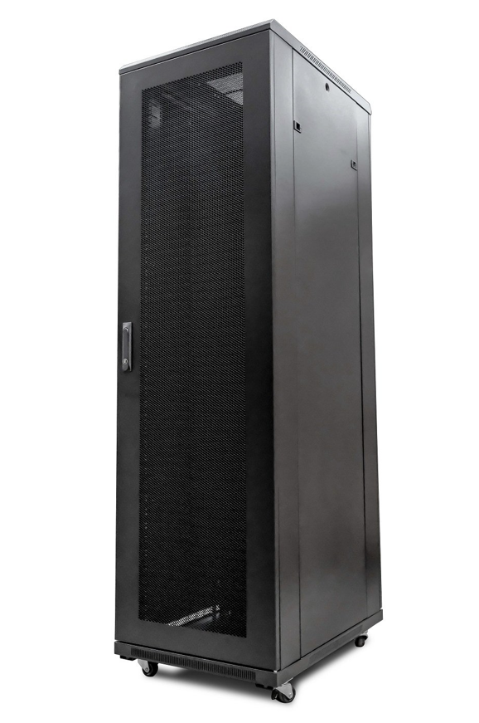

DESCRIPTION
Redefining Cost Effective Data Centre Enclosure Solutions
Wanting a cost-effective, no bundled accessory universal server
enclosures for your business?
The new range of LMS Data ValuCab 1000mm deep universal enclosures are
probably just what you are looking for. No bundled accessories such as fan trays
or shelving, just a standard, UK assembled 19-inch enclosure available in a range of
popular sizes. With an extended enclosure depth
means you can deploy almost all rack mount servers from the likes of HP, IBM,
Dell and Fujitsu with minimal fuss*. Ideal for the extra deep form-factor also of
managed switches, SAN and of course rack-mount power solutions, the LMS Data
ValuCab is ideal for both private and public sector deployments.
LMS Data does not skimp on the accessories you will always need, these
included ball-raced castors and fitted jacking feet to help deploy the ValuCab in
its ideal position, securely.

SPECIFICATIONS
ETSI 19" front/rear profiles, adjustable
Lockable mesh front door, reversible if required
Removable side panels, rear lockable door
Ideal for Dell(tm), IBM(tm), Fujistsu(tm) servers
Supplied with Castors and Jacking Feet
UK Assembled and quality assured

TECHNICAL INFO
SKU/MPN: CAB-FE-36U-6100NA
EAN: 8400800031228
Weight: 100.0 Kg
Dimensions: 600x1000x1780mm

FILES
Datasheet - CAB-FE-36U-6100NA

